Deep Learning

**MULTIMODAL CLASSIFICATION**

ASSIGNMENT 2

horizontal line

# FC Neural Network

### Hyperparameters

* 1. Learning rate (0.01, 0.001)
  2. Optimizer (sgd, adagrad, adam, rmsprop)
  3. Loss
     1. Only the sparse categorical cross entropy works as the output is digit and not 1 hot encoding, else we should have used categorical cross entropy.
  4. Activations functions (Sigmoid, Relu, Tanh)
     1. The activation function for the output layer must be softmax

### (Using default LR and relu activation function) [Optimizer HP]

|  |  |  |  |  |
| --- | --- | --- | --- | --- |
| Optimizer | SGD | Adagrad | RMSprop | Adam |
| Train-Acc | 0.91 | 0.91 | 0.981 | 0.983 |
| Test-Acc | 0.92 | 0.91 | 0.975 | 0.976 |
| Graph | sgd_opt | adagrad_opt | rmsprop_opt | adam_opt |

### (Using relu activation function) [Learning rate HP]

|  |  |  |  |  |
| --- | --- | --- | --- | --- |
| Optimizer | RMSprop | | Adam | |
| LR | 0.01 | 0.01 | 0.01 | 0.001 |
| Train-Acc | 0.978 | 0.981 | 0.975 | 0.983 |
| Test-Acc | 0.967 | 0.975 | 0.963 | 0.974 |
| Graph | rmsprop_0.01 | rmsprop_0.001 | adam_0.01 | adam_0.001 |

### (Using Adam and LR = 0.001 ) [Activation HP]

|  |  |  |  |
| --- | --- | --- | --- |
| Activation | Sigmoid | Relu | tanh |
| Train-Acc | 0.966 | 0.982 | 0.981 |
| Test-Acc | 0.964 | 0.976 | 0.973 |
| Graph | sigmoid_act | relu_act | tanh_act |

### Analysis

* 1. Best optimizer: Adam and RMSprop with Adam slightly better
  2. Best Learning rate: 0.001 with both Adam and RMSprop
  3. Best Activation Function considering the best optimizer with best LR: Relu slightly better than tanh.

### Observation

* 1. Test accuracy never reached the training accuracy
  2. Overfitting happens some of the time

# Convolution Neural Network

### Hyperparameters

* 1. Activation (Relu, Tanh)
  2. Filter size (3, 5, 7)
  3. Stride length (1, 2, 4)
  4. Pool layers (2, 3, 4)
  5. Dropout (hidden/input - 0.2/0.4)

### Fixing other parameters to see best Activation (3x3, 1, 2 maxpool)

|  |  |  |
| --- | --- | --- |
| Activation | Relu | Tanh |
| Train-Acc | 0.994 | 0.991 |
| Test-Acc | 0.991 | 0.986 |
| Graph | Relu_act | Tanh_act |

### Fixing other parameters to see best Filter size and stride (relu, 2 maxpool)

|  |  |  |  |  |  |  |  |  |  |
| --- | --- | --- | --- | --- | --- | --- | --- | --- | --- |
| Size | 3x3 | | | 5x5 | | | 7x7 | | |
| Stride | 1 | 2 | 3 | 1 | 2 | 3 | 1 | 2 | 3 |
| Train-Acc | 0.994 | 0.971 | 0.969 | 0.994 | 0.988 | 0.981 | 0.991 | 0.978 | 0.983 |
| Test-Acc | 0.988 | 0.97 | 0.965 | 0.991 | 0.984 | 0.98 | 0.986 | 0.972 | 0.981 |
| Graph | fig_1 | fig_2 | fig_3 | fig_4 | fig_5 | fig_6 | fig_7 | fig_8 | fig_9 |

#### Observation:

Decreasing the stride length always result in better accuracy and the opposite  
 happens with the filter size, as size increase the accuracy increases till an overfitting  
 happens

### Fixing other parameters to se best num of maxpool layers

|  |  |  |  |
| --- | --- | --- | --- |
| Maxpool num | 2 | 3 | 4 |
| Train-Acc | 0.994 | 0.99/0.992 | 0.985 |
| Test-Acc | 0.989 | 0.988/0.989 | 0.985 |

### 

### Fixing other parameters and using dropout as HP

|  |  |  |  |  |
| --- | --- | --- | --- | --- |
| Position | Hidden | | Input | |
| prob | 0.2 | 0.4 | 0.2 | 0.4 |
| Train-Acc | 0.99 | 0.98 | 0..99 | 0.986 |
| Test-Acc | 0.98/0.99 | 0.99 | 0.987 | 0.984 |

### Model Analysis

Analysis is done for one Model, however it could be repeated to all similarly  
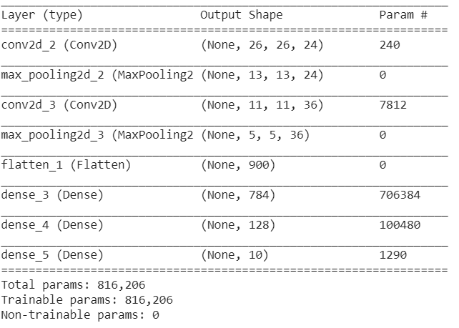

* 1. Running time = 26 sec
  2. Number of parameters = 816,206
  3. Number of multiplications
     1. Training = 60,000 * ( (26*26*24*3*3*1) + (0) + (11*11*36*3*3*24) + (0) + (784*900) + (784*128) + (128*10)) * 5
     2. Testing = 10,000 * ( (26*26*24*3*3*1) + (0) + (11*11*36*3*3*24) + (0) + (784*900) + (784*128) + (128*10))

### Comparison to FC NN

|  |  |  |
| --- | --- | --- |
| Model | FC-NN | CNN |
| Train Accuracy | 0.982 | 0.994 |
| Test Accuracy | 0.974 | 0.991 |
| Time | 23.46 sec | 26.0 sec |

# Appendix

### FC NN

## Optimizers

#### Sgd

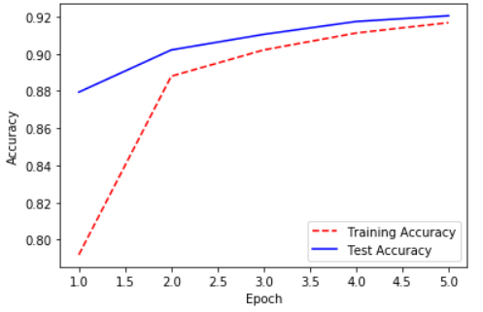

#### Adagrad

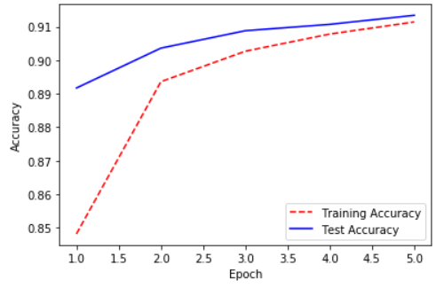

#### Rmsprop

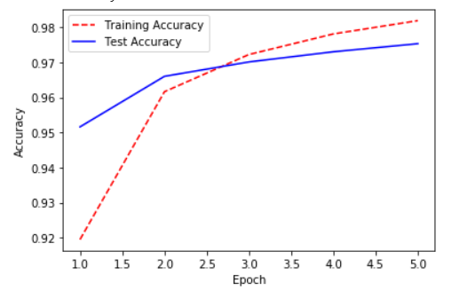

#### Adam

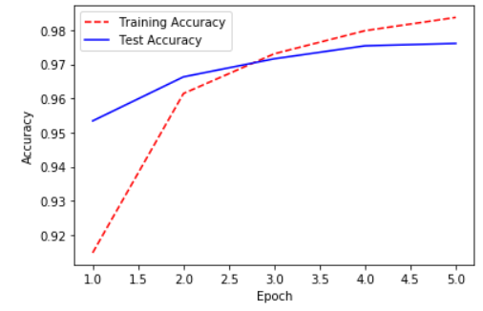

## LR

#### Adam_0.01

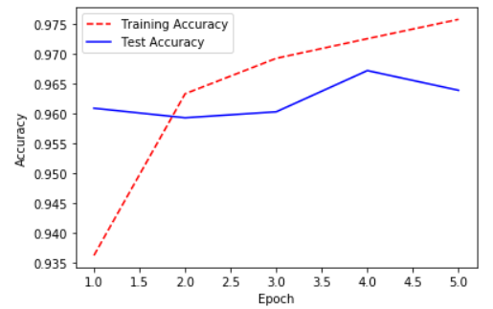

#### Adam_0.001

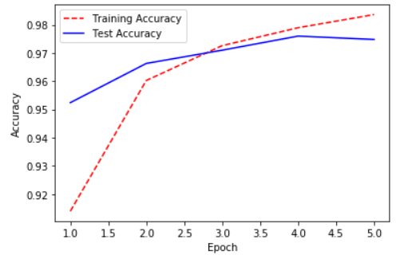

#### RMSprop_0.01

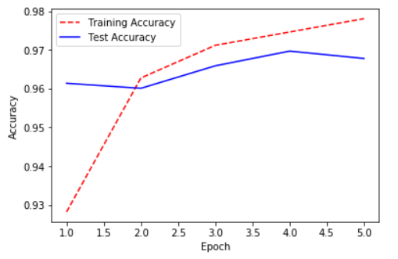

#### RMSprop_0.001

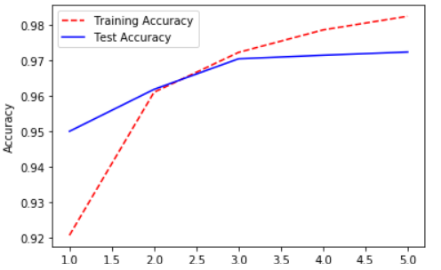

## Activation

#### Sigmoid

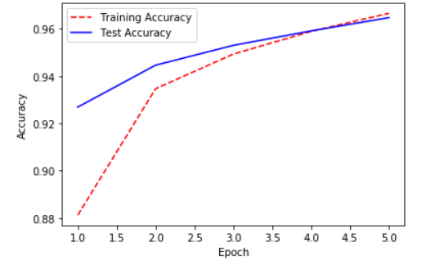

#### Relu

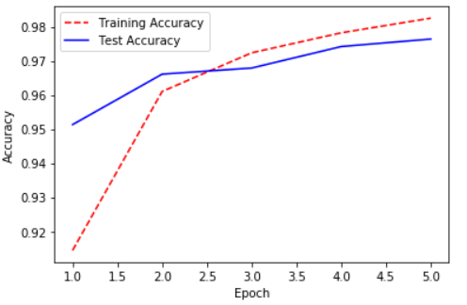

#### Tanh

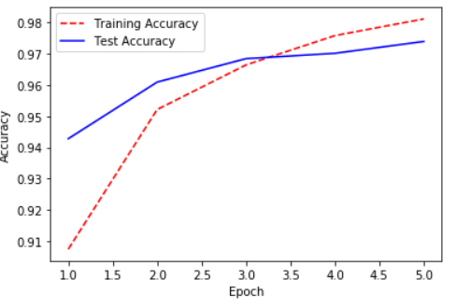

### CNN

## Activation

#### Relu

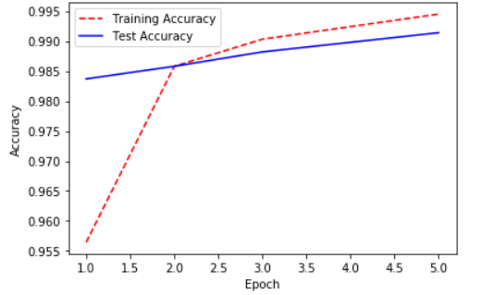

#### Tanh

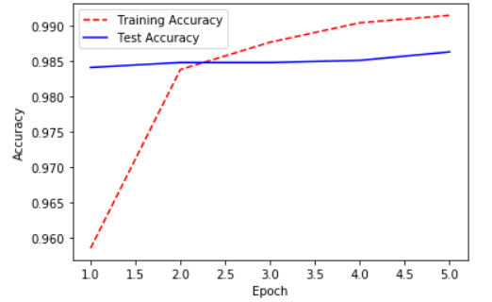

## Filter size & Stride

#### 3x3_1

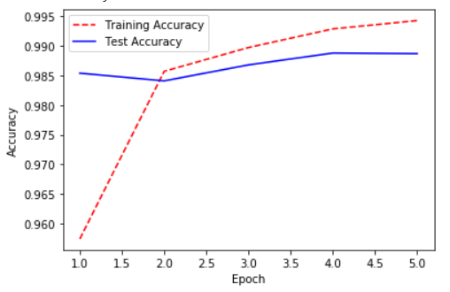

#### 3x3_2

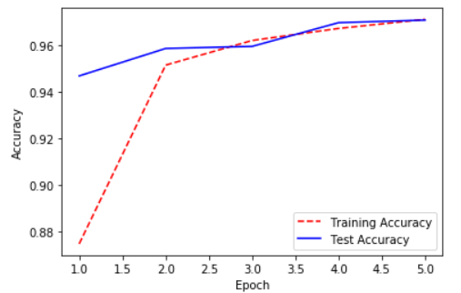

#### 3x3_3

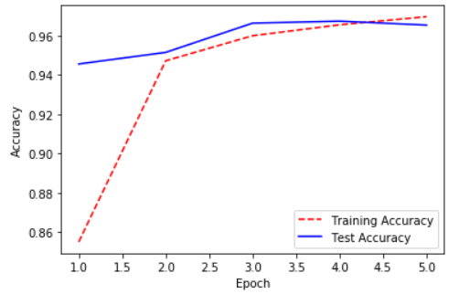

#### 5x5_1

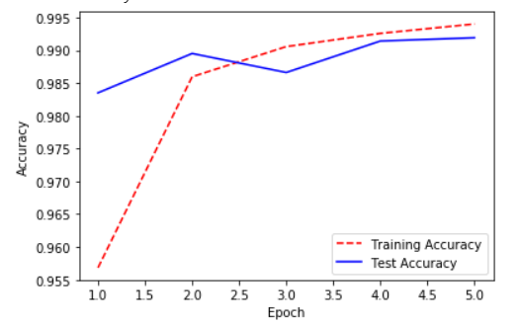

#### 5x5_2

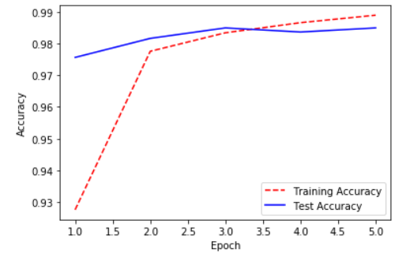

#### 5x5_3

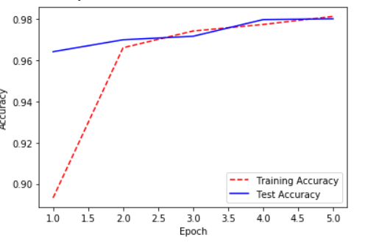

#### 7x7_1

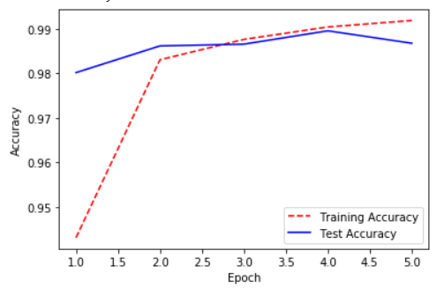

#### 7x7_2

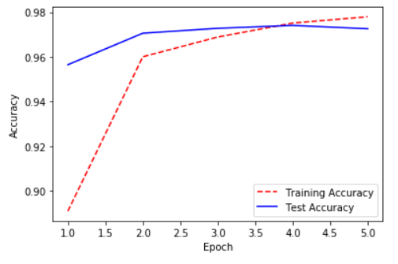

#### 7x7_3

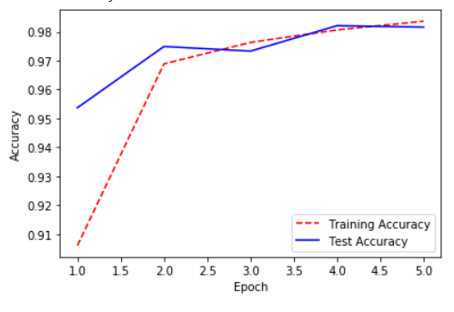

* 1. .